Running **Hydra.java** with head equaling size 4

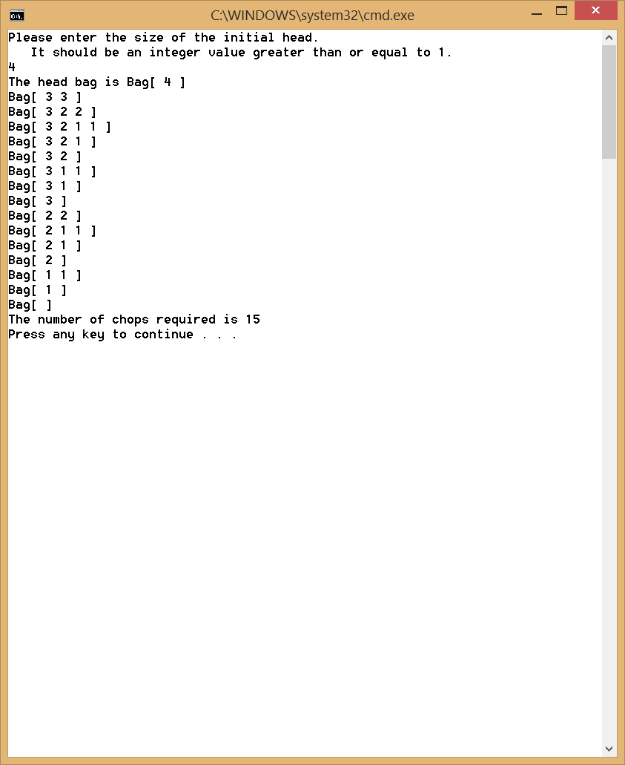

Running **Hydra.java** with head equaling size 5 (Overflow Expected)

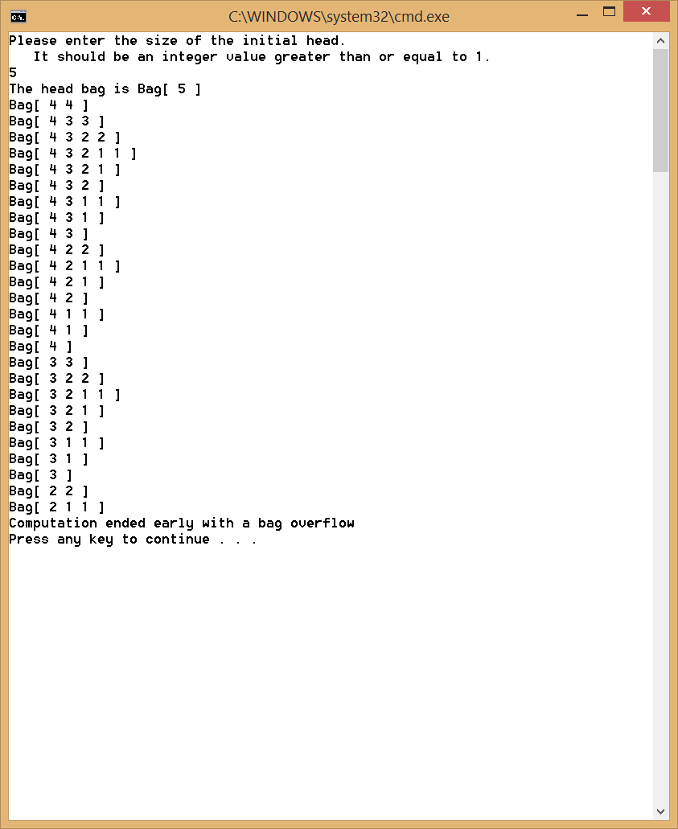

Running **LongestCommonSubsequence.java** and finding Subsequence

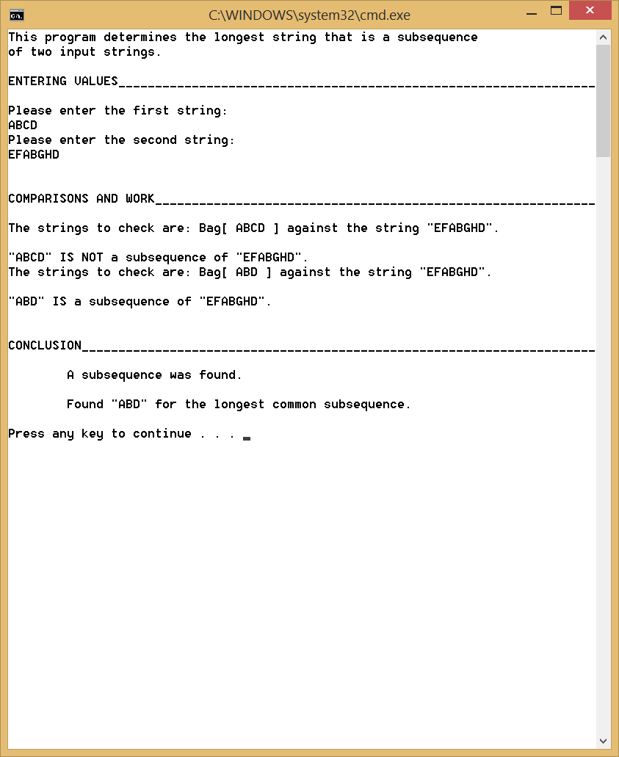

Running **LongestCommonSubsequence.java** and NOT finding Subsequence

